Answer
Lesson 7 : Area and volume (A)

How to calculate the area of the following shapes?

$$d_{1}$$
$$d_{2}$$
$$A=\frac{d_{1}d_{2}}{2}$$

$$A=l^{2}$$
$$A=lw$$

$$A=\frac{bh}{2}$$

$$A=bh$$

$$A=\frac{b_{1}+b_{2}}{2}h$$

$$A=πr^{2}$$
$$A=πr^{2}×\frac{θ}{360}$$

Checkpoint 1

Volume of Prism and Cylinder

Total Surface Area of right Prism and Cylinder

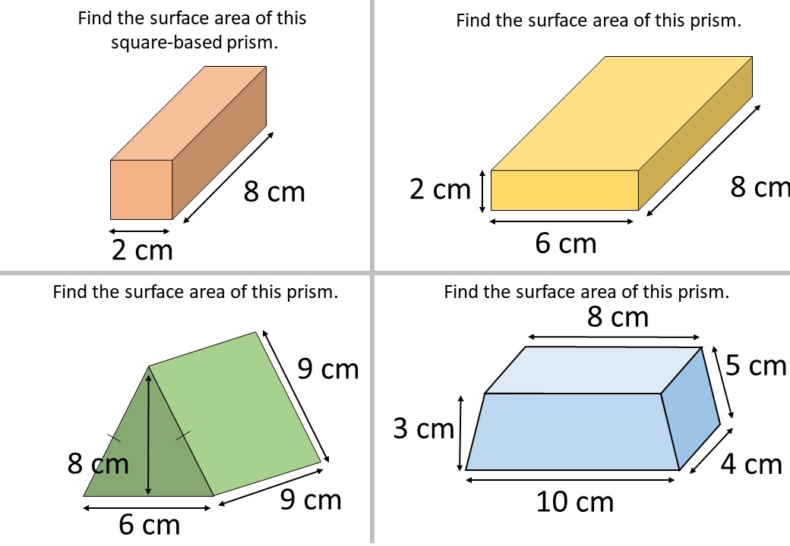
Volume of Prism = Base area$×$Height

Volume of Cylinder $=πr^{2}h$

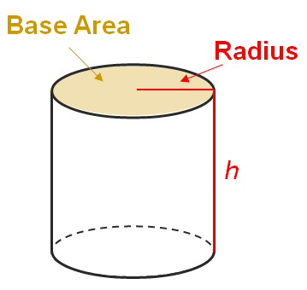

TSA of right Prism
= Base area$×\text{2}+$Perimeter of Base$×$Height

TSA of right Cylinder = $\text{2}πr^{\text{2}}+\text{2}πrh$

Find the volume and the total surface area of the following right solids (in terms of $π$ if needed). (Q1-3)
1.

2

3
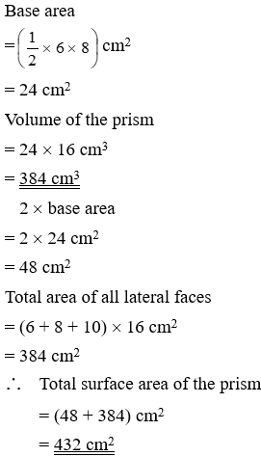

10 cm
16 cm
6 cm
8 cm

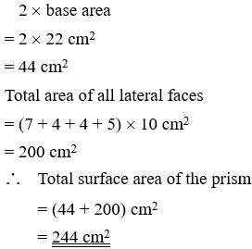
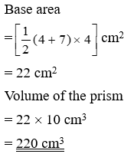
5 cm

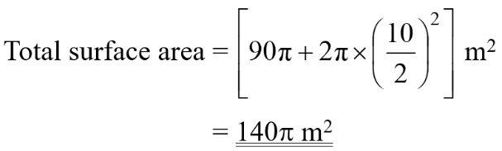
$$\text{Vol}\text{ume of the cylinder} \\ =\left[π{\left(\frac{\text{10}}{\text{2}}\right)}^{\text{2}}×\text{9}\right] {\text{m}}^{\text{3}} \\ =\text{225}π {\text{m}}^{\text{3}}$$
10 m
9 m

4. The total surface area of a right cylinder and the circumference of its base are 1 312π mm² and 32π mm respectively. Find its
(a) height, (b) volume. (Give the answers in terms of π if necessary.)

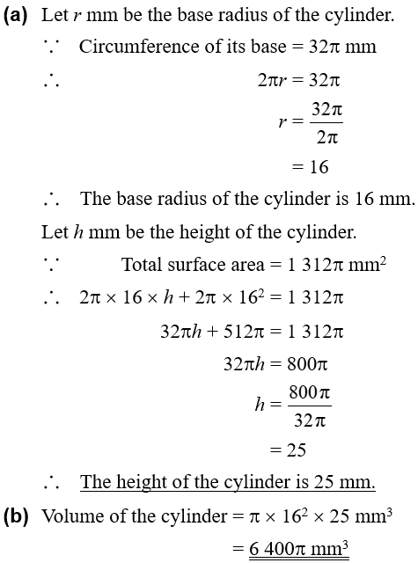




Checkpoint 2

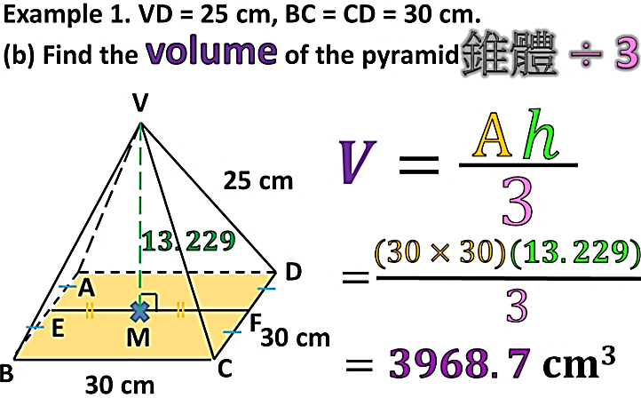
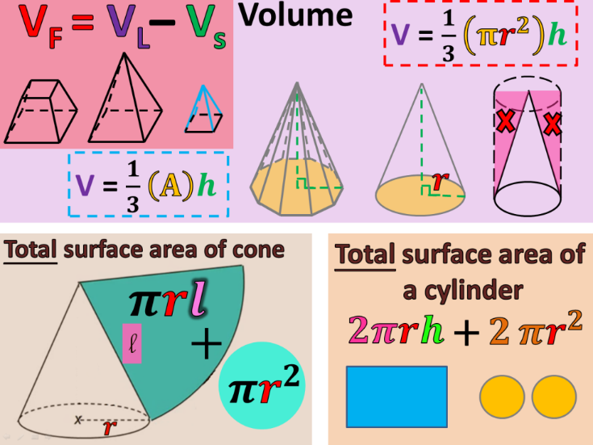
Volume of Pyramid and Cone

Volume of Cone $=\frac{\text{1}}{\text{3}}πr^{\text{2}}h$
Volume of Pyramid = $\frac{\text{1}}{\text{3}}×$Base area$×$Height

Find the volume of the following solids (in terms of $π$ if needed). (Q5-7)
45 cm
16 cm
5. 6. 7.

5 mm
12 mm
9 mm
6 cm
4 cm
5 cm

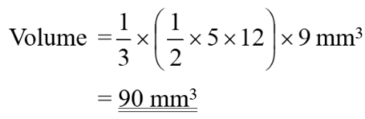
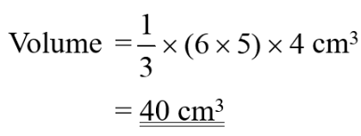
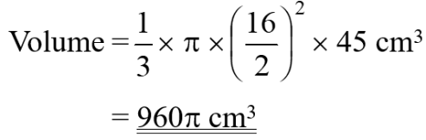

8. Lucy has eight identical cups in the shape of inverted right circular cones. The base diameter and the height of each cup are 9 cm and 14 cm respectively. Can the eight cups hold orange juice of volume 2 250 cm³? Explain your answer.

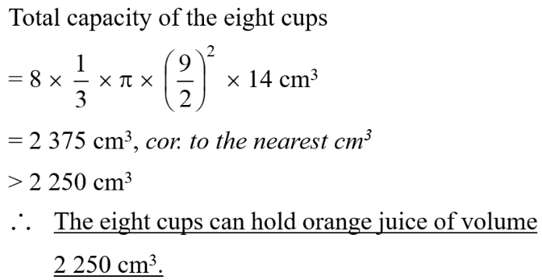

9. The figure shows a pyramid VPQR whose height is VP. The base of the pyramid is a right-angled triangle PQR, where PQ$\text{⊥ }$QR. It is given that VQ = 7.5 m, PQ = 6 m and QR = 10 m.
(a) Find the height of the pyramid.
(b) Find the volume of the pyramid.

10 m
V

P
Q
R
7.5 m
6 m
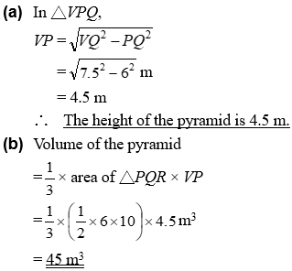


10. The figure shows a right pyramid ABCDE with a rectangular base BCDE. The diagonals BD and CE intersect at N. AD = 26 cm, BC = 12 cm and CD = 16 cm.
(a) Find the lengths of ND and AN.
(b) Find the volume of the pyramid.

12 cm
16 cm
26 cm
A

B
C

D

E

N

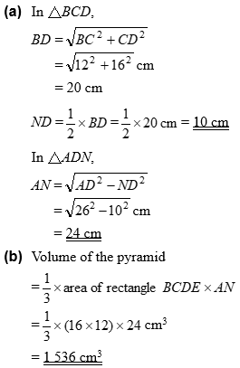



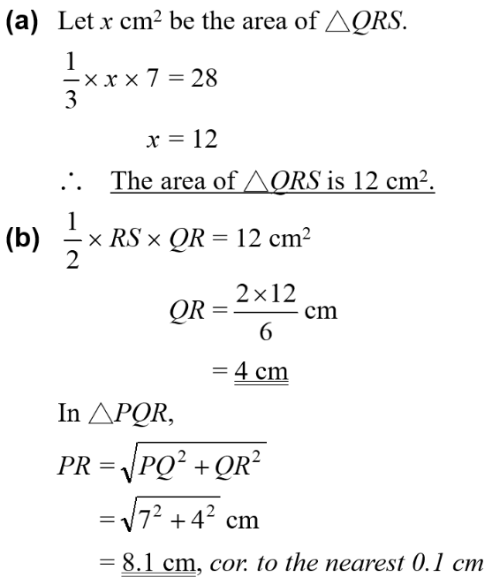
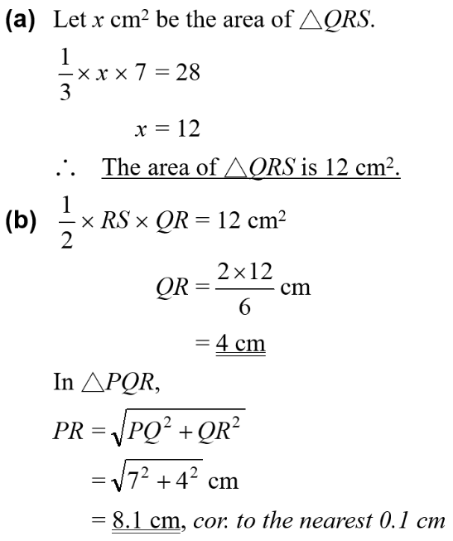
11. The base of the pyramid in the figure is a right-angled triangle QRS, where QR$\text{⊥ }$RS and RS = 6 cm. The height PQ of the pyramid is 7 cm. If the volume of the pyramid is 28 cm³,
(a) find the area of △QRS,
(b) find the lengths of QR and the slant edge PR.
(Give the answers correct to the nearest 0.1 cm if necessary.)

P
Q
R
S
7 cm
6 cm

12. The figure shows a pyramid. The base of the pyramid is a regular hexagon with side length of 6 cm. The height of the pyramid is 12 cm. Find the volume of the pyramid.

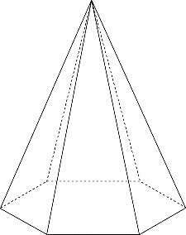
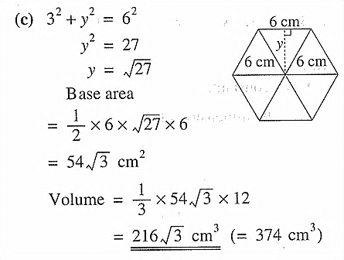

Checkpoint 3


Curved surface area of Cone

Total surface area of Cone

$$=πrl$$
$$=πr^{2}+πrl$$

For each right circular cone in Q13-15 find
(a) the curved surface area, (b) the total surface area. (Give the answers in terms of π.)
13. 14. 15.

4 cm
8 cm
3.6 mm
1.5 mm
20 m
33 m

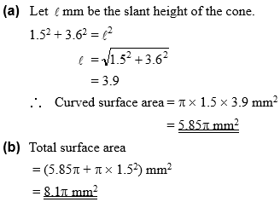
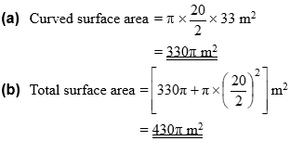
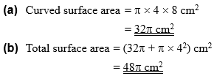

V

R
Q
P
V

S
N
34 cm
30 cm
V

V

16. The cardboard in the figure is the net of a regular pyramid. PQRS is a square. It is given that VN = 30 cm and VQ = 34 cm.
(a) Find the length of PQ.
(b) Find the total surface area of the pyramid.

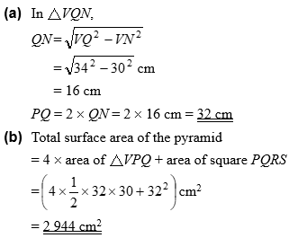


17. The figure shows a food tent without base. It is in the shape of a right pyramid with square base BCDE. If BC = 60 cm and AB = 50 cm, find the total surface area of the tent.
A

B

C

D

E

60 cm
50 cm
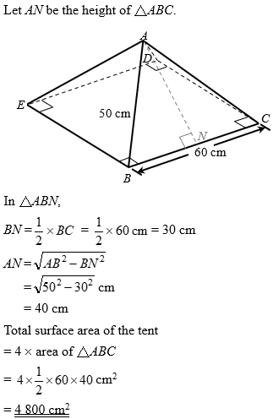




18. In the figure, the volume of a right circular cone is 96π cm³ and its height is 8 cm.
(a) Find the base radius of the circular cone.
(b) Find the slant height of the circular cone.
(c) Find the total surface area of the circular cone in terms of π.

8 cm

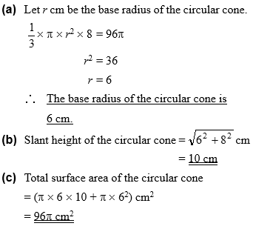



19. The base radius and height of a right circular cone are 11 cm and 60 cm respectively.
(a) Find the slant height of the circular cone.
(b) Find the total surface area of the circular cone in terms of π.

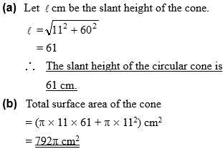


20. Fig. A shows a glass filled up with apple juice. It is in the shape of an inverted right circular cone of base radius 9 cm and height 15 cm. All the juice in the glass is poured into an empty cylindrical vessel of base radius 6 cm (as shown in Fig. B). Find the depth of the juice in the cylindrical vessel.

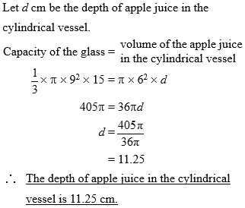
15 cm
9 cm
6 cm
Fig. A
Fig. B

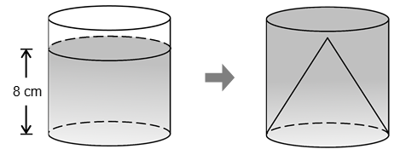
21. In the figure, the depth of the water in a cylindrical container is 8 cm. After a solid right circular cone with height 9 cm and the same base radius is put into the container, the water level rises to the top of the container. Find the height of the container.

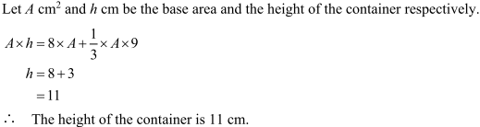

22. Consider a regular pyramid A with a square base and a right circular cone B. It is given that the length of a side of the square base of pyramid A is the same as the base radius of cone B. If the two solids have the same volume, which solid will have a greater height? Explain your answer.

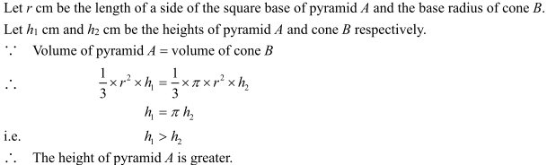

23. A chocolate cuboid with dimensions $\text{12.5}\text{ cm}×\text{ 4 cm}×\text{4} \text{cm}$. It is melted and recast into some identical right circular cones of base radius 1.5 cm and height 2.4 cm. What is the maximum number of cones that can be made?

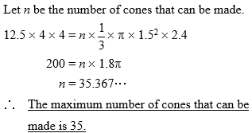

24. Fig. A shows a paper cup in the shape of an inverted right circular cone.
(a) Find the capacity of the paper cup.
(b) The paper cup is cut along PQ to form the sector in Fig. B. Find
(i) the area of the sector,
(ii) the angle of the sector.
(Give the answers correct to 3 significant figures.)

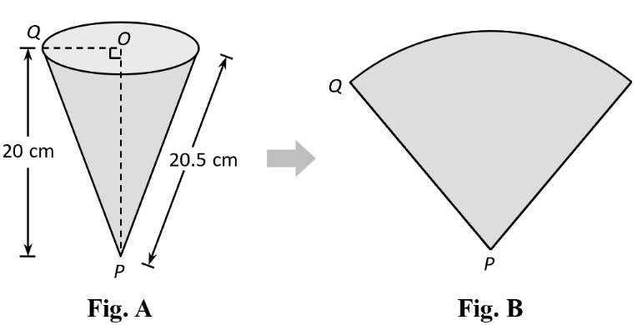

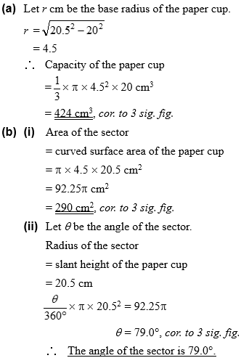





25. Fig. A shows a sector. It is folded into an inverted right circular cone as shown in Fig. B.
(a) Find the base radius of the cone.
(b) Find the capacity of the cone.
(Give the answer correct to 3 significant figures.)

